DIOCESE OF CUMBERLAND
The Progressive Episcopal Church

LETTER OF FACULTIES-Priest

Rev. ____________________________, a Priest in the Church of God, you have been called to work together with your Bishop and fellow-Presbyters as a pastor, priest, and teacher, and to take your share in the councils of the Church.
Now, in accordance with the traditions of the Church, you have been selected to serve God in the Diocese of Cumberland.
This letter is a sign that you are fully empowered and authorized to exercise this ministry, accepting its privileges and responsibilities as a priest of this Diocese, in communion with your Bishop.
Having committed yourself to this work, do not forget the trust of those who have chosen you. Care alike for young and old, strong and weak, rich and poor. By your words, and in your life, proclaim the Gospel. Love and serve Christ's people. Nourish them, and strengthen them to glorify God in this life and in the life to come.
May the Lord, who has given you the will to do these things, give you the grace and power to perform them.
Given under my hand and seal, in the city of Seward, in the state of Nebraska, on the ___________day of __________________, 2015, and in the third year of my episcopate.

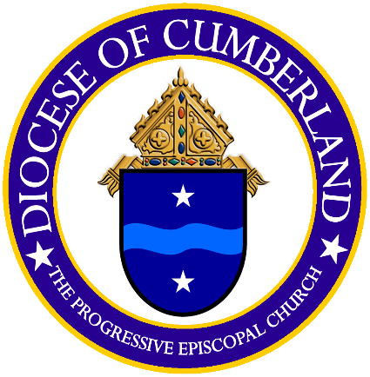
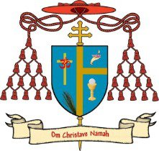
The Rt. Rev. Michael W. Sherbert

Bishop Diocesan
Diocese of Cumberland
The Progressive Episcopal Church

