DIOCESE OF THE WEST
The Progressive Episcopal Church

LETTER OF FACULTIES - Priest

____________________________, a Priest in the Church of God, you have been called to work together with your Bishop.
Now, in accordance with the traditions of the Church, you have been selected to serve God in the Diocese of the West.
This letter is a sign that you are fully empowered and authorized to exercise this ministry, accepting its privileges and responsibilities as a deacon of this Diocese, in communion with your Bishop.
Having committed yourself to this work, do not forget the trust of those who have chosen you. Care alike for young and old, strong and weak, rich and poor. By your words, and in your life, proclaim the Gospel. Love and serve Christ's people. Nourish them, and strengthen them to glorify God in this life and in the life to come.
May the Lord, who has given you the will to do these things, give you the grace and power to perform them.
Given under my hand and seal, in the city of Lubbock, in the state of Texas, on the ___________day of __________________, 2015, and in the XXXX year of my episcopate.

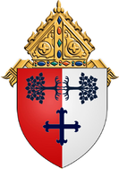
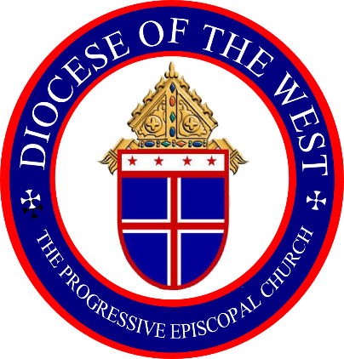

The Rt. Rev’d Mansell C. Gilmore, SC
Bishop Diocesan
Diocese of the West
The Progressive Episcopal Church

