Certificate of Incardination

To all the faithful in Jesus Christ,
Greetings.
Be it known that

a priest of the Church in succession of the Apostles
was incardinated into the

Diocese of the West

in accordance with the Canons of the Progressive Episcopal Church
together with all faculties, rights, privileges and responsibilities appertaining thereto,
on this the day of in the year of our Lord 2015.

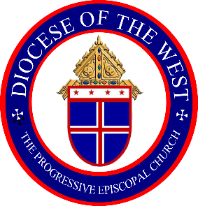
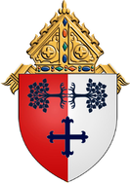

_______________________________
Rt. Rev. Mansell C. Gilmore, SC
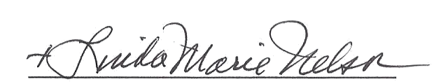
Bishop Diocesan

