Ministry License

The bearer of this Ministry License is authorized to execute the ministries and pastoral functions detailed below:

• Baptize and teach disciples of Jesus Christ
• Preach and teach in areas assigned by the Bishop
• Conduct non-eucharistic public services of worship and devotion
• Provide pastoral ministry services for which they are trained
• Execute parochial pastoral ministry services in cooperation with the Bishop or deacons and priests delegated by the Bishop
• Perform the Rite of Burial of the Dead
• Additional functions as authorized by the Bishop.
- Officiate marriage in compliance with state and local law.

This ministry license is valid for one year from the date of issuance and may be suspended or revoked by the issuing Bishop at will. Licensed ministers must report their ministry and pastoral activities in writing to the Bishop at least once per calendar month.

Ministry License

To all the faithful in Jesus Christ,

Greetings.

Be it known that

is hereby granted this

Ministry License

and is authorized to execute the ministries
and pastoral functions detailed by the Bishop
This license is valid until __________________.

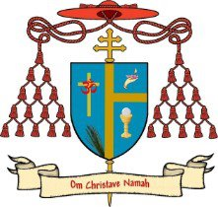
________________________________ Date _________________
Rt Rev. Michael W. Sherbert
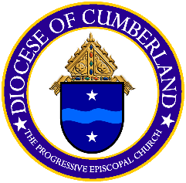
Bishop Diocesan of Cumberland
The Progressive Episcopal Church

